Contents

I. INTRODUCTION 2

II. ES6 3

1. Arrow Functions 3

2. Enhanced Object Literals 3

3. Destructuring 3

4. Spread 5

5. JS Modules 5

III. REACT, REACT DOM 6

1. document.createElement() 6

2. Add React to your project 6

3. React.createElement() 7

4. React DOM 8

IV. JSX, COMPONENTS AND PROPS 9

1. JSX 9

2. React Element Types 10

# INTRODUCTION

SPA: Single Page Application

MPA: Multi-Page Application

CSR: Client-Side Rendering

SSR: Server-Side Rendering

|  |  |
| --- | --- |
| **SPA** | **MPA** |
| * Modern * Trending * Page reloading is not required * Most necessary resources is loaded on the first run * Only need to load new resources when needed * Back-end and front-end independence * Not SEO friendly as MPA * Better user experience on mobile devices * JS dependency * Client-side rendering -> Reduce load for server | * Traditional * Need to reload page * Need to reload the entire page when accessing or routing * More SEO friendly than SPA |

# ES6

## Arrow Functions

-Reduce code length:

Normal:

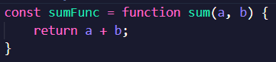

Arrow:



-To return an object with arrow functions, we must put the object inside **()**:



-If there is **only 1 argument**, we can ignore **()**:



-Arrow function **does not have context** => **Cannot use *this***

## Enhanced Object Literals

-In **reduce()** function, we must remember to return **accumulator**

## Destructuring

-Destructure an array:

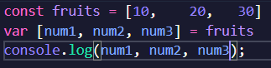

-Destructure an object:

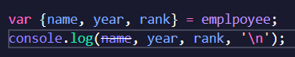

-Rest operator **…var**

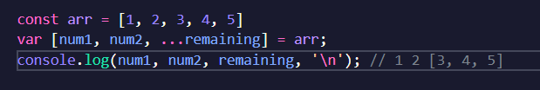



-Change variable’s name when working with objects:

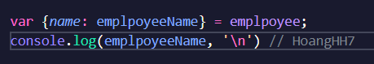

-Omit some elements in the aray.

**Ex:** [10, 20, 30]

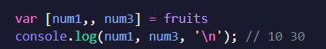

## Spread

-Use the spread operator to “remove” **[]** or **{}**

-Concatenating arrays:

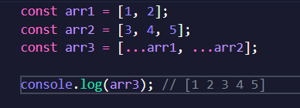

-Concatenating objects:

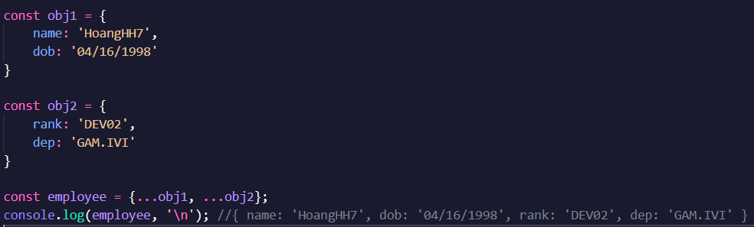

## JS Modules

**export default** <function>

**import** <function> **from** <file>

# REACT, REACT DOM

## document.createElement()

-How JS can render HTML elements ?

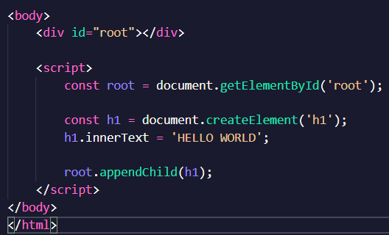

## Add React to your project

-**NPM** = Node Package Manager

-**UNPKG**

+ Acquire NPM packages as CDN

+ Syntax:

**unpkg.com/:package@:version/:file**

-To add React with UNPKG, use following script:

<script crossorigin src="https://unpkg.com/react@17.0.0/umd/react.production.min.js"></script>

## React.createElement()

-React element is the smallest component of the React library.

-**React.createElement(**<type>, <props>, <childrens…>**)**. Children is also considered as **props**.

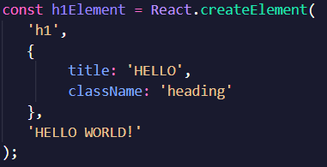

-Create element with multiple levels:

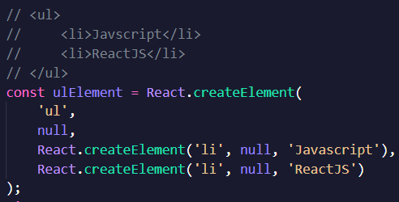

## React DOM

-Bridge between React and DOM

-ReactDOM supports rendering React elements.

-Add ReactDOM:

<script crossorigin src="https://unpkg.com/react-dom@17.0.0/umd/react-dom.production.min.js"></script>

-Syntax:

**ReactDOM.render(**<element>, <container>**)**

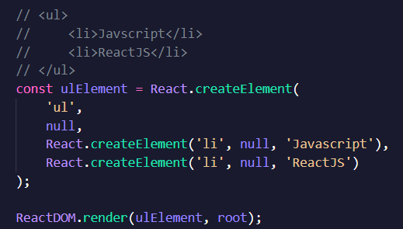

# JSX, COMPONENTS AND PROPS

## JSX

-**JSX** = Javascript XML. **JSX** is **NOT HTML**.

-**Babel** translates XML to React code.

-Put JS code inside **{}** of **JSX**.

  
  
  
**=>**

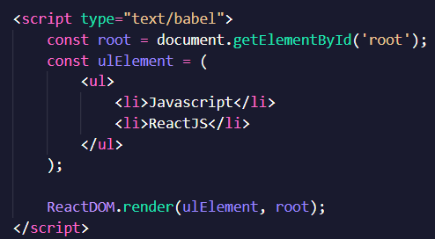

**-**Dynamically creates React elements from an array:

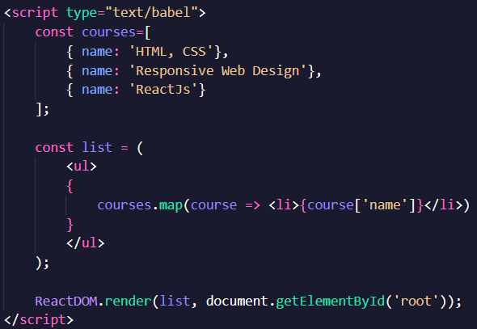

**-Array.map()**: Create a new array with modification to elements. **Map()** is often used for creating React elements from an array.

## React Element Types

-**React.createElement()** support types: function, class and string.

-Function component:

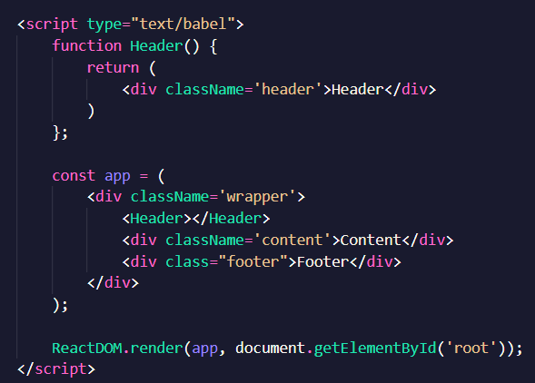

## Props

-Is used to pass data from parent components to child components. It is similar to passing arguments to functions.

-Use props like attributes of a HTML tag:

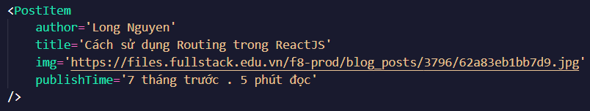

-To access an attribute, we can use: **props.<***attribute_name***>**

